**Digital Nurture 4.0 Java FSE**

**Week 6 ReactJS - HOL**

**Mandatory Exercise (HandsOn 1)**

**Exercise 01:** Create a new React Application with the name “myfirstreact”, Run the application to print “welcome to the first session of React” as heading of that page.

**Answer:**

**App.js:**

import React from 'react';

import GreetingCard from './components/GreetingCard';

function App() {

return (

<div className="App">

<GreetingCard />

</div>

);

}

export default App;

**GreetingCard.js:**

import React from 'react';

function GreetingCard() {

return (

<h1>Welcome the first session of React</h1>

);

}

export default GreetingCard;

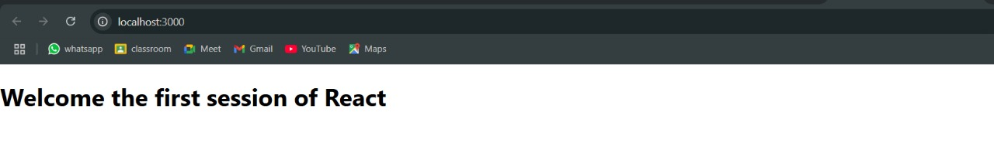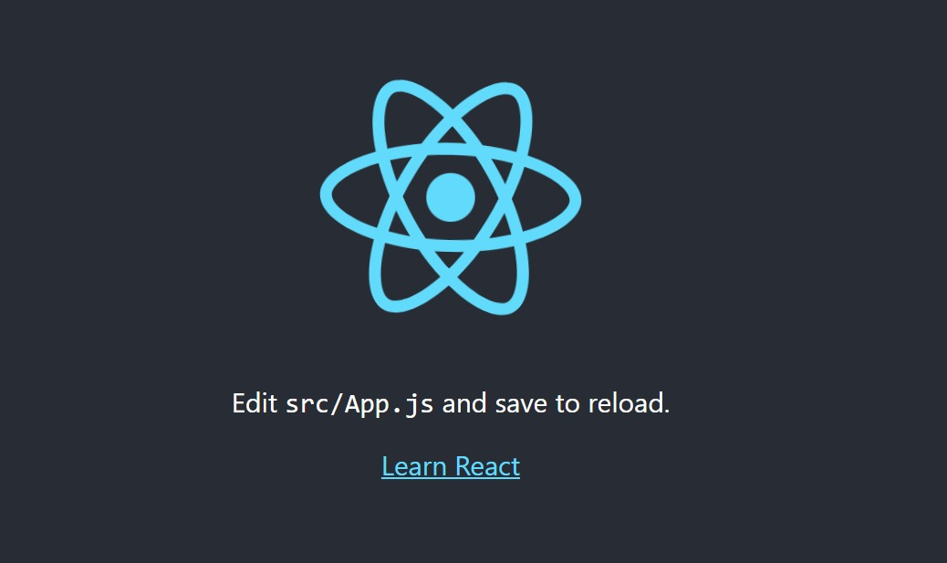**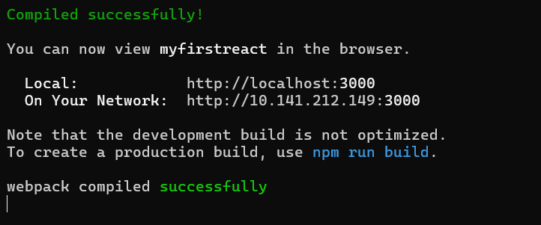Output:**